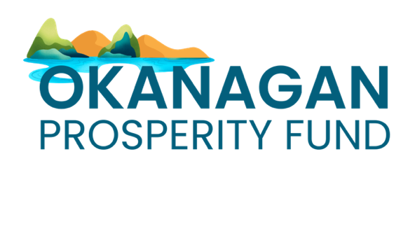

Fund Guidelines

The Community Prosperity Fund
The Community Prosperity Fund is a $25 million investment from the Government of B.C. that advances poverty reduction and social inclusion—announced on the inaugural B.C. Nonprofit Day.
The Community Prosperity Fund is part of the Government of B.C.’s commitment to supporting the non-profit sector and empowering local communities to make local decisions through local community foundations.

The Okanagan Prosperity Fund
Community Foundation North Okanagan, Central Okanagan Foundation, and Community Foundation of the South Okanagan Similkameen are uniting resources to create lasting change. By collaborating on funding through the Okanagan Prosperity Fund, we are focusing on upstream solutions that address the root causes of poverty, ensuring that social inclusion and opportunity are within reach for all in our communities.
This funding is intended to create deep impact through providing larger grants to a smaller number of organizations that are closely aligned with our vision for long-term change and provide upstream solutions for addressing poverty and improving social inclusion.

Capacity Enhancement: Impact Measurement

Organizations receiving Okanagan Prosperity Fund grants will also be invited to participate in a specially designed impact measurement training cohort. Understanding and demonstrating the true impact of their work allows organizations to refine their strategies and better serve their communities.

Timeline
- August 26: Call for letters of interest (LOI) opens
- September 13: Call for LOI closes
- September 13-27: LOI are reviewed
- September 30: Full application opens for invited organizations
- October 18: applications close
- October 18-November 8: Applications are reviewed
- November 15: Notifications
- January 2025: Grant payments and impact measurement cohort begins
- June 30, 2027: Grant activities must end

Eligibility
Eligible organizations meet the following criteria:
- You support communities in the North Okanagan, Central Okanagan or South Okanagan Similkameen
- You are a charity, non-profit organization, or an Indigenous-serving organization, and;
- You have not received funding from the Lighthouse Operations Fund, Recovery & Resilience Fund, or Level BIPOC Grants

Eligible Activities
Eligible organizations can apply to the Okanagan Prosperity Fund for operational expenses or project delivery. You get to decide what would benefit your organization most so that you can advance your activities and the incredible work that benefits your community.
This program welcomes collaborative applications. Preference will be given to projects, programs or organizations working on upstream solutions to social inclusion and/or poverty reduction.

Activity Examples:
- A charity that focuses on jobs for new immigrants is applying so they can continue to pay their rent and operate out of the same building
- An Indigenous-serving organization is applying to develop a coalition on food security in their region

Ineligible Activities
- Activities that take place outside of the North, Central, or South Okanagan Similkameen
- Major capital activities, including building infrastructure, purchasing land or buildings
- Partisan, political or election-related activities
- Activities that generate profit, including direct fundraising activities or events
- Activities that benefit only private interests
- Activities that undermine, restrict or infringe on human rights legally protected in Canada
- Sub-granting activities
- Sponsorship, endowment funds and donations

Ineligible Expenses
- Expenses incurred before June 30, 2024
- Expenses incurred after June 30, 2027
- Expenses that have already been paid for by another funding source
- Purchasing land or buildings, real estate fees and related costs
- Setting aside funds for losses of potential future liabilities and contingencies
- Legal penalties, including fines and other punitive measures
- Taxes for which an organization is eligible for a tax rebate
- Costs associated with profit-making activities, including fundraising activities
- The financing of deficits
- Political activities supporting or opposing any political party, elected representative, or candidate for public office
- Activities which are religious or include a requirement to part any dimensions of faith or that only benefit your members
- Capital renovations or repairs of premises used exclusively for religious observance or practice
- Activities, projects or services carried out or provided outside of Canada

Funding Limits
We have not indicated a grant maximum with this fund, but we anticipate the typical grant will be approximately $50,000, for applications submitted to Central Okanagan Foundation and Community Foundation of the South Okanagan Similkameen. For applications submitted to the Community Foundation North Okanagan, the typical grant will be $20,000 to $35,000.
- Larger investments may be considered for organizations whose work reaches across two or more regions.

How to Apply
Organizations may submit one LOI for funding. The LOI will be accepted through online portals which can be accessed through each participating foundation’s website (linked below). Those organizations that are invited to submit a full application will use the same portal.
Apply in the region where you primarily offer services:
- Community Foundation North Okanagan
- Central Okanagan Foundation
- Community Foundation of the South Okanagan Similkameen

Additional Support
Community Foundation North Okanagan:
Leanne Hammond
250-542-8655
Leanne@cfno.org
Central Okanagan Foundation:
Abbie Norrish
250-861-6160 ext 101
abbie@centralokanaganfoundation.org
Community Foundation of the South Okanagan Similkameen:
Kevin Ronaghan
236-500-1243
kevinronaghan@cfso.net

